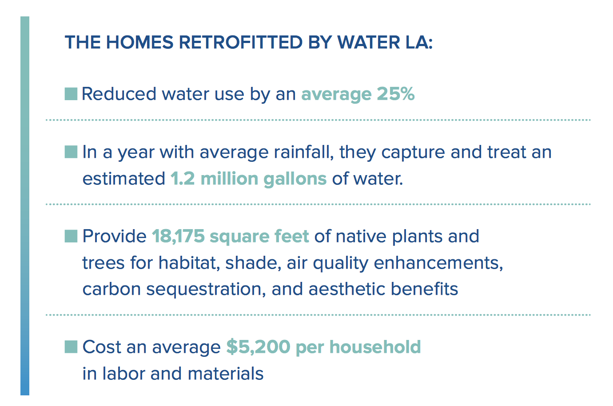 Of key significance: given the small-scale, relatively low-tech nature of the projects, a substantive rollout of the program could likely be carried out more quickly and cost-e ectively than a more- engineered green streets program. In contrast to an approach that requires digging up streets and building underground chambers for water storage, the techniques we deployed can be adopted
by residents with minimal assistance from municipal agencies. Many property owners already spend significant time and money on landscape care and maintenance. Education, incentives, and readily available materials can support residents in making massive impacts on resource conservation without increasing municipal expenditures, and potentially even saving money.
Page 8 Introduction
Page 9-10-11 Project Background, Lynne Plambeck photo of Santa Clara River
Page 12-13 Nature-Based Solution to Stormwater Management

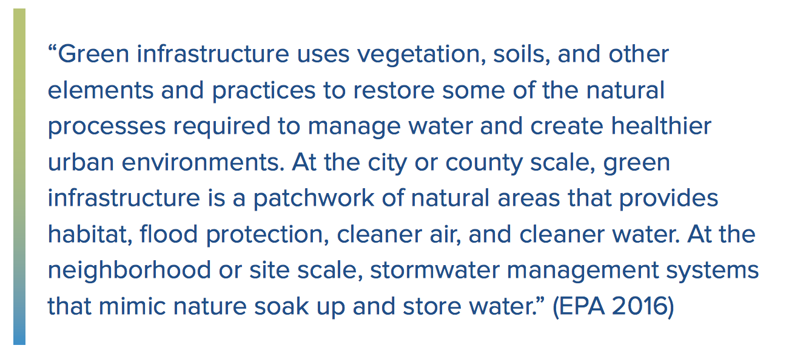

Page 15 Comparing Grey, Grey-Green, *Parcel-Based Retrofits (Nature Based Solution) Better in every way.

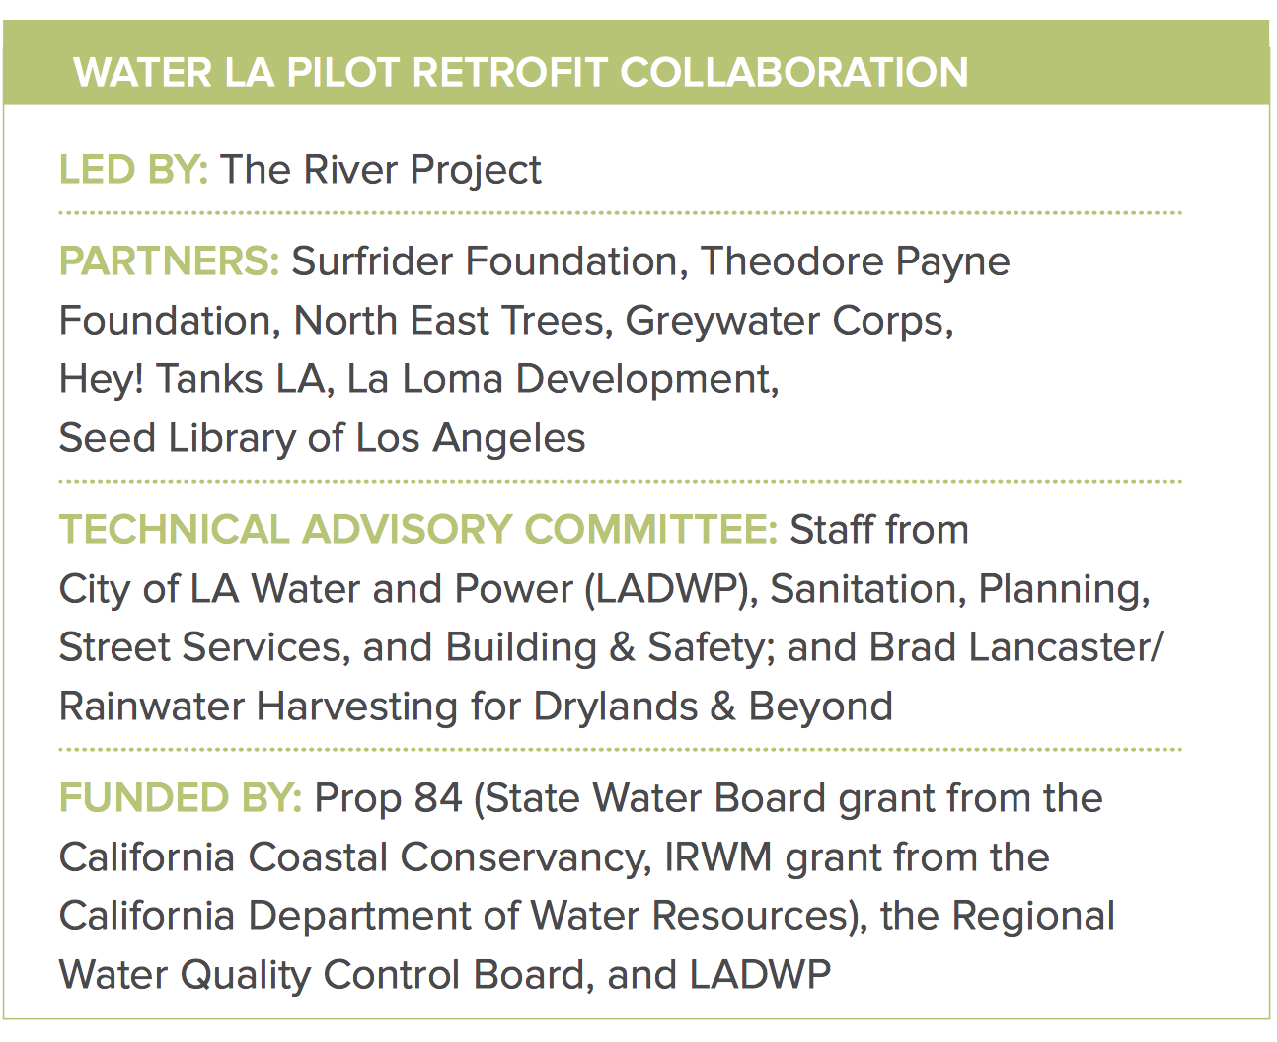

Page 23 Parkway Retrofits and Permeable Paving
Page 24 Greywater Systems and Infiltration Trenches
Page 25 Site Assessment

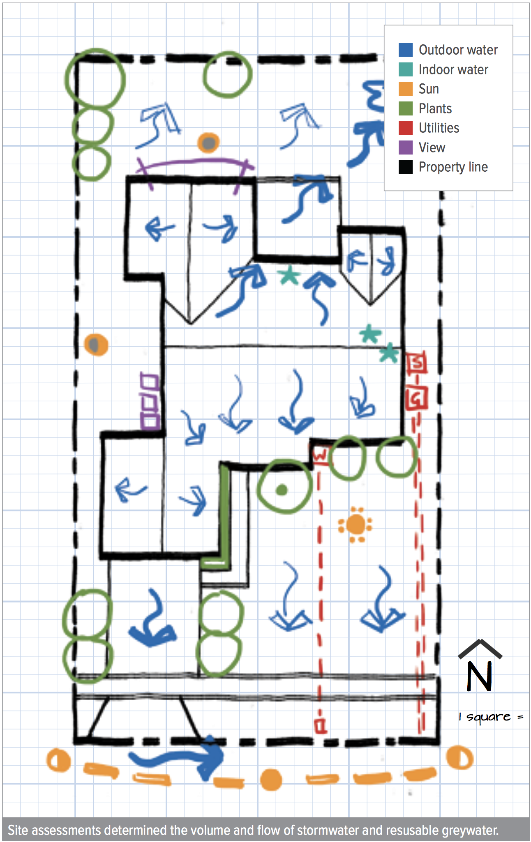

Pages 27-39 Results of LA Retrofits – Statistics by Household / Community Benefits

Page 40-44 Key Findings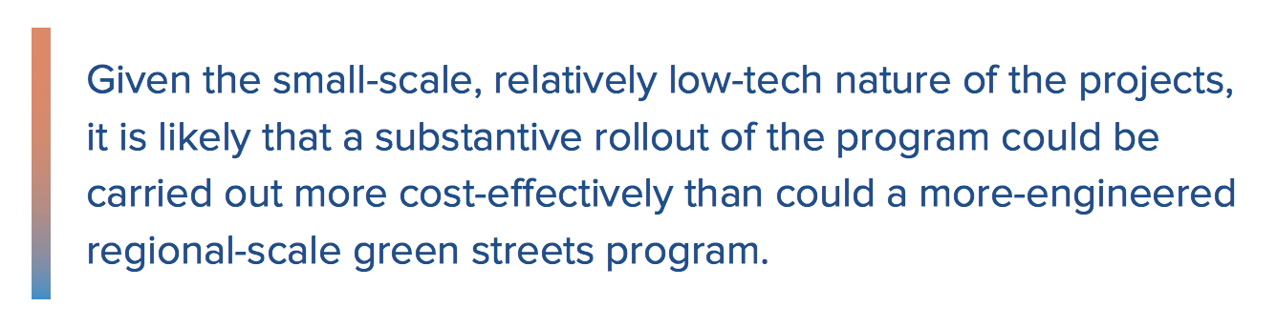
Pages 45-49 Policy Recommendations and Conclusions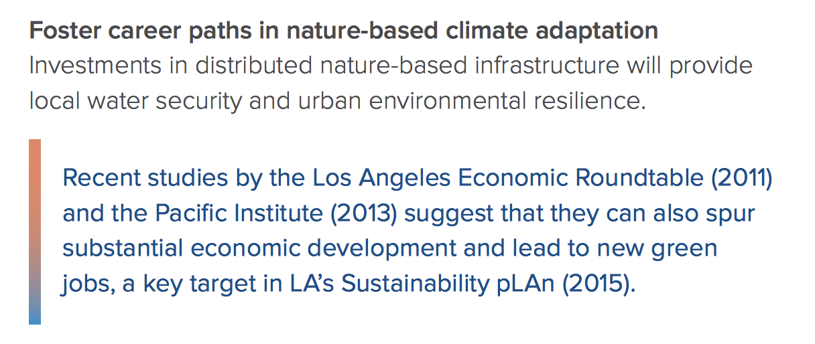
Pages 49-54 Appendices
Pages 55 Watersheds and Waterways – Note exclusion of Ballona Watershed.
Pages 56-99 Appendices

